CHAROTAR UNIVERSITY OF SCIENCE AND TECHNOLOGY
Chandubhai S. Patel Institute of Technology
Matrusanstha Department of Mechanical Engineering

Event Report

Theme of Event | Application of AI in Mechanical Engineering
Title of Event | Industrial visit to MEDITAB (INDIA) PVT. LTD., Ahmedabad
Type of Event | Academic Visit
Objective of Event | To provide quality education by exposing first-year students to advanced technology and practical applications of AI and automation at MEDITAB, thereby enhancing their understanding of AI, bridging the gap between theoretical knowledge and real-world applications, and motivating them towards the latest technological trends and research-oriented learning.
Mode of Conduct | Offline
Level of Activity | Level-2 (5-7 Hours)
Date & Time of Event: | 15/04/2026 from 09:00 am to 04:00 pm
Event Convener | Dr. Vijay Chaudhary, Dr. Ashwin Makwana
Event Coordinator/s | - Dr. Sagar Chokshi  - Dr. Kawaljitsingh Randhawa
Target Audience | B.Tech. First and Second year (Mechanical) students
Name of the Expert (if Any) | -
Affiliation of Expert | -
Number of participants | 26
Key Output of Activity  with KPIs | - At least 90% student participation with active engagement during the visit to MEDITAB.  - Minimum 80% of students demonstrate improved understanding of AI and automation, measured through post-visit feedback and assessment.
Pre-Event Social Media Links | https://www.facebook.com/share/p/1GkeSTDpKK/
Post-Event Social Media Links | https://www.facebook.com/share/p/1E6TwK5mKP/

Attachments:
- Annexure 1: Event Poster
- Annexure 2: Expert/Event Details
- Annexure 3: Event Photographs
- Annexure 4: Attendance
- Annexure 5: Feedback

Coordinator/s’ Name and Sign:
 | 
Dr. Kawaljit Randhawa | Dr. Sagar Chokshi

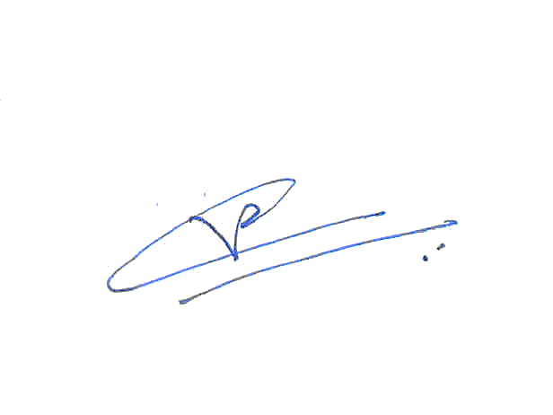
Head of the Department Sign:
Event Description and Key Outcomes of the Event/Activity:

The primary aim of the visit was to bridge the gap between theoretical knowledge and practical exposure in the field of AI in mechanical engineering. The objectives included:
- To familiarize students with real-world applications of AI.
- To understand the fundamentals of AI and its potential applications in mechanical engineering.
- To expose students to modern research facilities and technologies used in Pharma Packaging industries.
- To encourage interest in research and innovation among students.
During the visit, students gained valuable insights into the applications of AI and automation in packaging industry. They learned about:
- The working of pharma packaging industry.
- Different automated material handling devices/instruments.
- The role of accuracy and precision in pharma packaging.
- The importance of repeatability in production.
- The role of interdisciplinary knowledge in solving engineering problems.
Overall, the visit provided students with practical exposure, enhanced their understanding of advanced technologies, and motivated them to explore research-oriented career opportunities in the field of AI.

Annexure 1: Event Poster

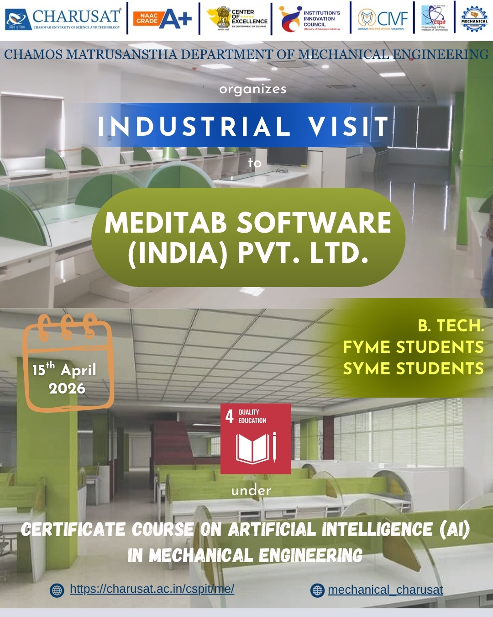
Annexure 2: Company Details

Name of Organization: MEDITAB Software (India) Pvt. Ltd., Ahmedabad

Email Address: hrindia@meditab.com
Mobile Number: 9099997711

MEDITAB is a leading software solutions provider in the healthcare industry. Their core EHR platform, Intelligent Medical Software (IMS), brings together EHR, practice management, billing, and office management into one, seamless system. MEDITAB developed solutions that address all aspects of healthcare, from mobile functionality and telemedicine, to an all-new suite of office management tools integrated with EHR, the Electronic Medical Office (EMO).

Annexure 3: Event Photograph(s)
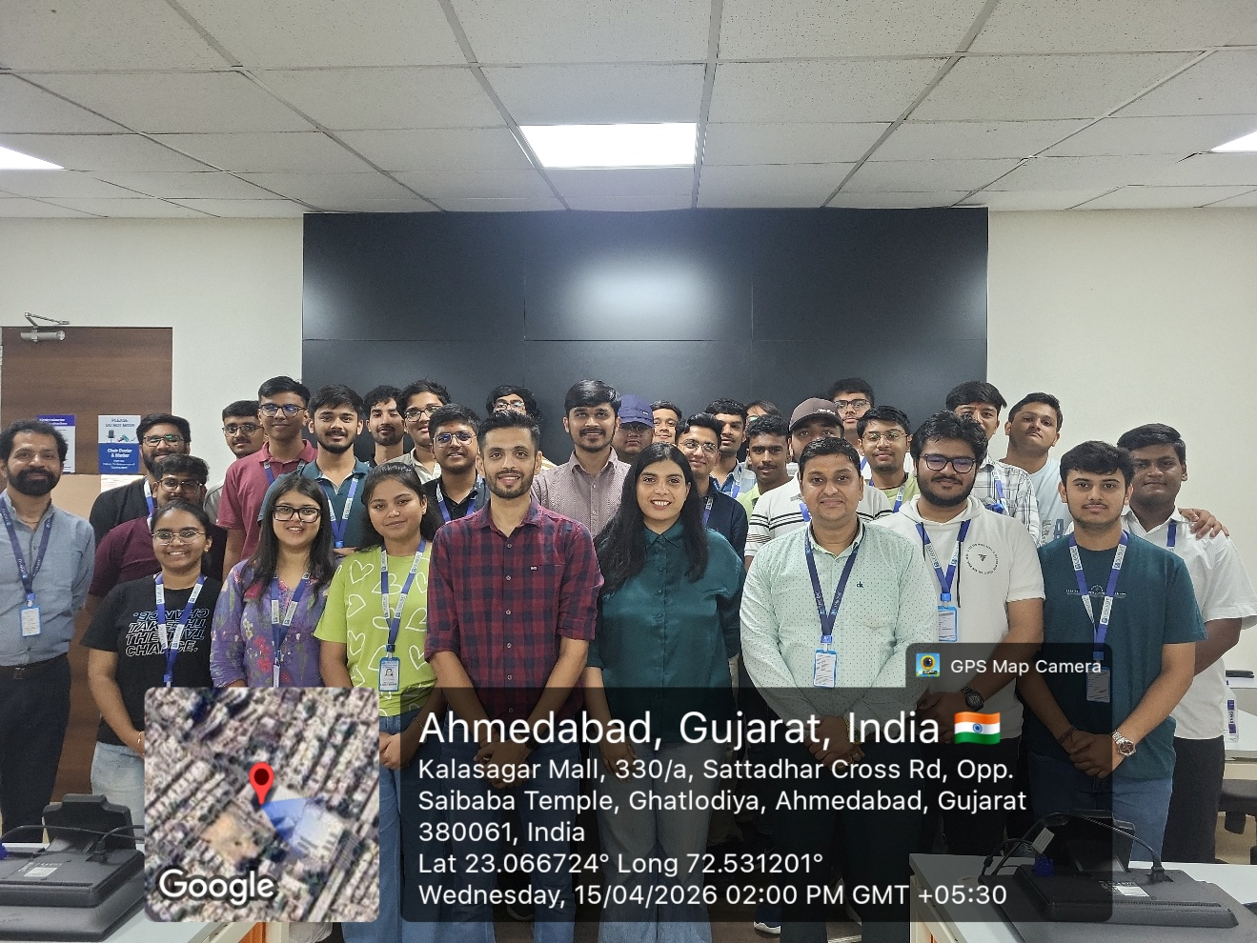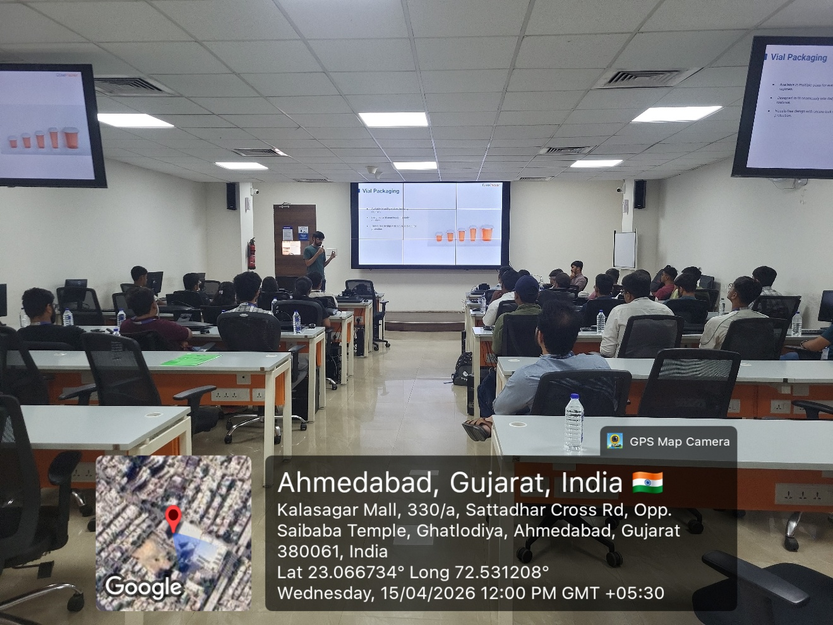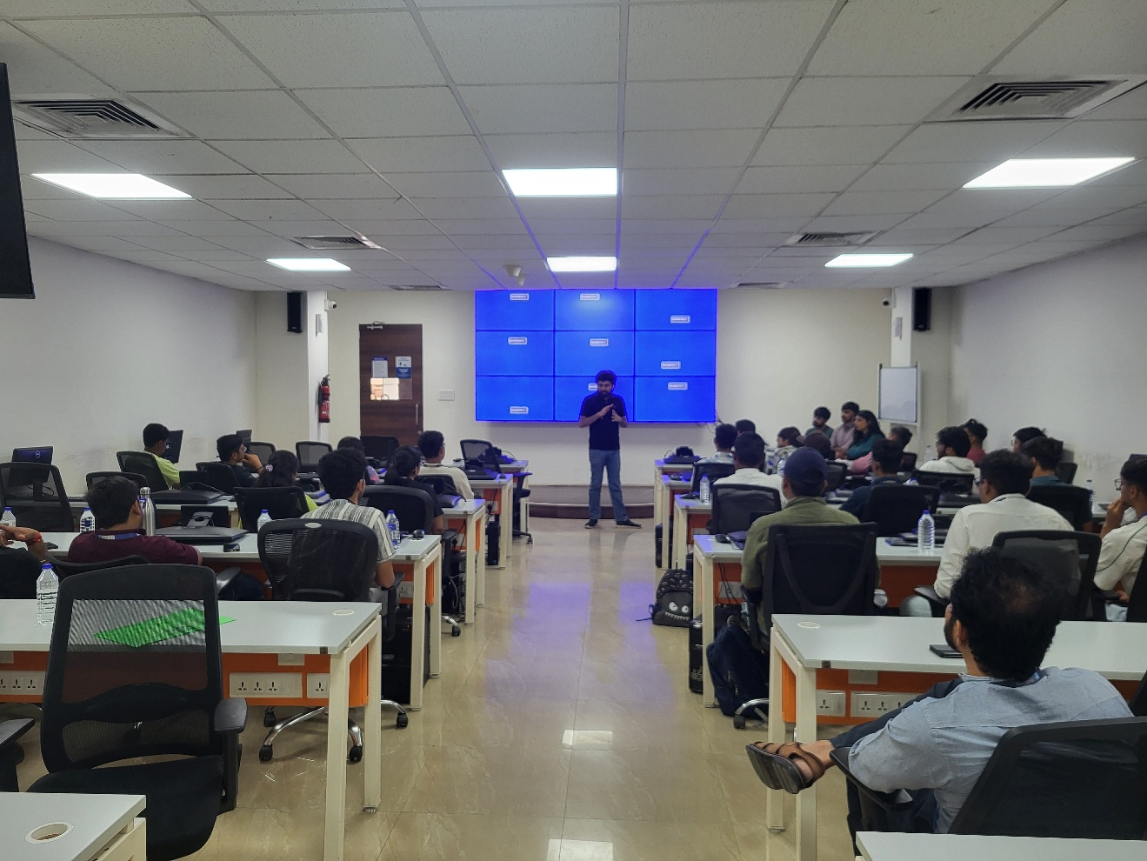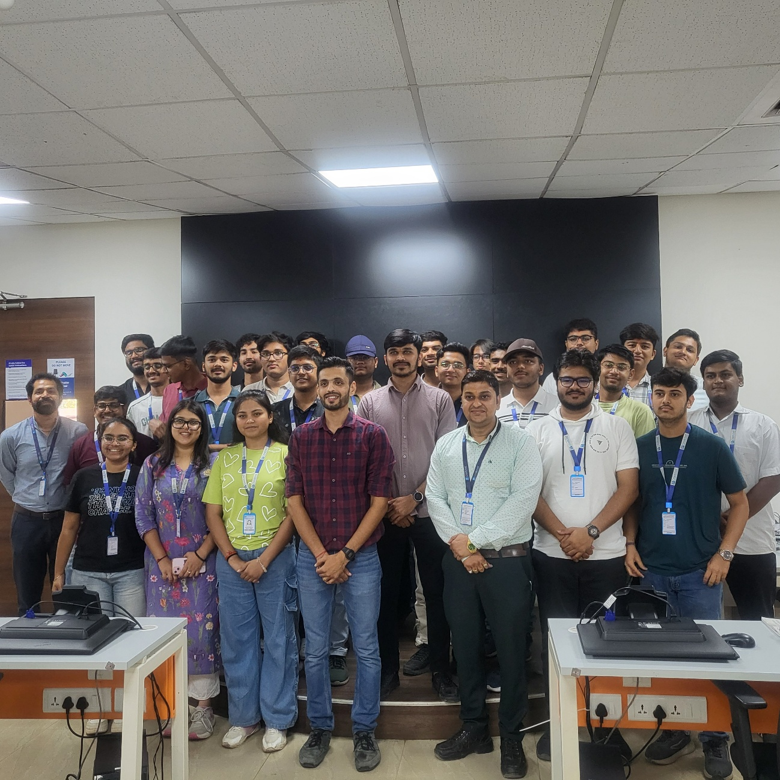

Annexure 4: Attendance

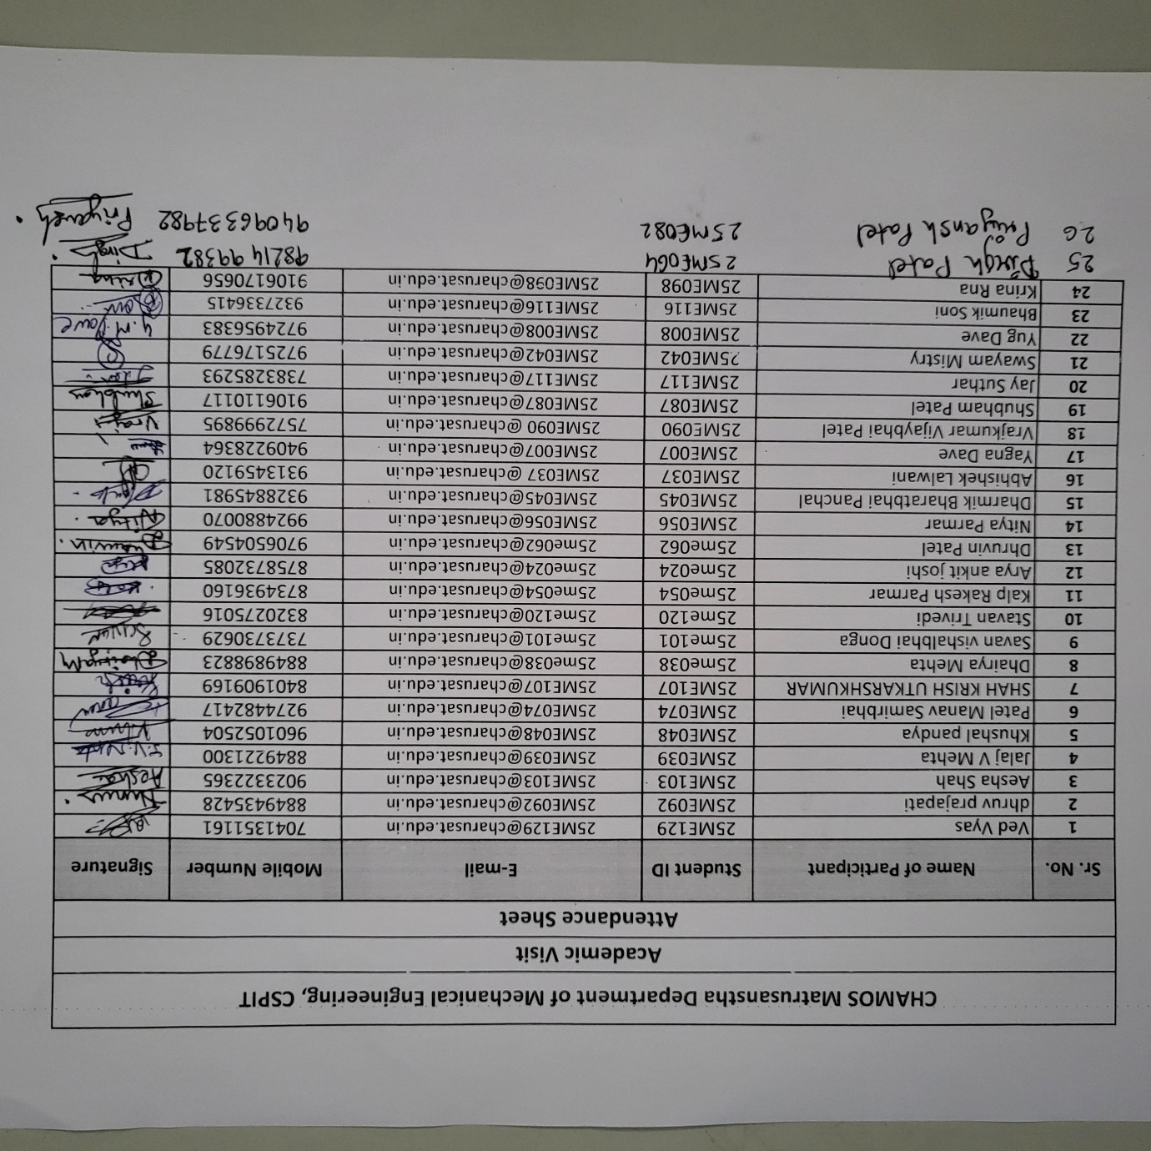

Annexure 5: Feedback
